## Coding Period Started

With the beginning of this month, GSoC Coding Period begins, I started working actively, I also had Video call with my mentor last week & we discussed a lot about this project & program. My mentors suggested me to first work on frontend of App ( Developing UI Screens ) with dummy data & later work on backend.

## Developing UI Screens of App with Dummy Data

This week I made UI screens of App with Dummy Data, I added Navigation Drawer, Bottom Navigation in app. I made UI of each screen. Some screens UI are pending but, I will do it by next week.

I will discuss here each screen I made with Dummy Data for now

### Home Screen

This screen will display nearby hospitals with images, It contains a search bar with settings icon which displays settings to change radius to display nearby hospitals.

I have tried to make search bar similar to Google Play Store Search Bar.

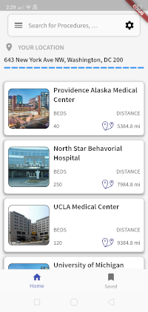

### Search Screen

It contains a search bar by which user can search for any procedure, It displays list of procedures

### Settings Screen

It displays a slider which can control radius of UI.

### Saved Screens

It will display list of chargemasters which are saved in local storage as SQL Database of App

### View CDM Statewise

User can view CDM of any hospital of any state

I have added Navigation Drawer which contains the following screens

* View CDM Statewise
* Compare Hospitals
* Share App
* About App
* Report a Bug

Bottom Navigation holds these UI

* Home Screen
* Saved CDM

I have to scrap CDM of Alaska State which I will do by Sunday & will send a Merge Request Soon,

## UI Sample Screens

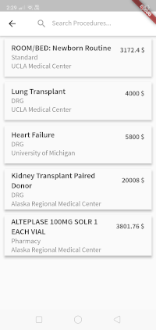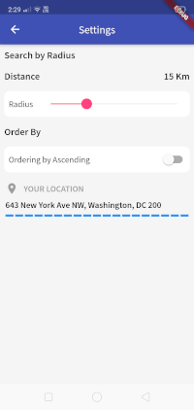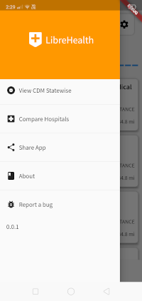

## 

## 

## What I plan to do next week?

I have planned make complete UI of App & to scrap CDM of California State. I will discuss with my mentors what more needs to be done or any suggestion needed.

## My Entire discussion with mentors can be seen here

<https://forums.librehealth.io/t/project-develop-an-android-mobile-application-to-show-patient-friendly-costs-of-care/3685/44>